http://secret-cities.com/2011/09/15/a-top-history-of-hats/

https://translate.googleusercontent.com/translate_c?act=url&depth=1&hl=en&ie=UTF8&prev=_t&rurl=translate.google.com&sl=auto&tl=en&u=http://de.wikipedia.org/wiki/Weida-Konferenz&usg=ALkJrhj3lTK0CKJEqW4oX6Ip4i1L_r197Q

https://translate.google.com/translate?sl=auto&tl=en&js=y&prev=_t&hl=en&ie=UTF-8&u=http%3A%2F%2Fde.wikipedia.org%2Fwiki%2FHeinrich_Tr%25C3%25A4nker&edit-text=&act=url

@book{jones2003anna,
title={Anna Wickham: A Poet's Daring Life},
author={Jones, J.V.},
isbn={9781568332536},
lccn={2003004656},
url={https://books.google.com/books?id=zv\_vD3hKdHMC},
year={2003},
publisher={Madison Books}
}

http://www.sacred-texts.com/eso/to/

Lady Harris husband

http://en.wikipedia.org/wiki/Sir_Percy_Harris,_1st_Baronet

this Butler knew Crowley

http://www.worldcat.org/title/trial-tr-by-willa-and-edwin-muir-revised-with-additional-chapters-and-notes-by-prof-em-butler/oclc/610298154

en.wikipedia.org/wiki/Eliza_Marian_Butler

Symonds neighborhood.

https://www.google.com/maps/@51.50972,-0.237553,3a,75y,281.71h,63.59t/data=!3m4!1e1!3m2!1s-elKqHQYAUExSCLDQBS3HA!2e0

http://www.victorianlondon.org/publications2/lookeron-9.htm

http://en.wikipedia.org/wiki/Hotel_Cecil_%28London%29

http://www.crowleyprojects.co.uk/docs/cecil.html

in SF at the http://www.sfpalace.com/

in Ny at the Imperial.

Shepheards Hotel Cairo Oct 25, 1902

Langham paris - where Crowley eloped with Rose

http://www.amazon.com/White-Stains-Nameless-FORBIDDEN-CLASSICS/dp/1902588916

r.h.s. truell

https://books.google.com/books/about/Catalogue_of_Printed_Books.html?id=8JdwcgAACAAJ&hl=en

aelfrida tillyard

http://en.wikipedia.org/wiki/Aelfrida_Tillyard

http://www.cambridge-news.co.uk/Heavy-hints-Cambridge-medium/story-22778412-detail/story.html

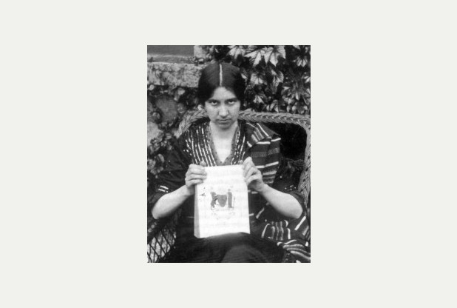

Published Works
Library resources about
Aelfrida Tillyard

- Resources in your library
- Resources in other libraries
By Aelfrida Tillyard
- Online books
- Resources in your library
- Resources in other libraries
- Le Livre des Jeux (Blackie & Co London) 1906
- To Malise (Heffer & Sons Cambridge) 1910
- Cambridge Poets 1900-1913 (Heffer & Sons Cambridge) 1913
- Bammie's Book (Heffer & Sons Cambridge) 1915
- The Garden and the Fire (Heffer & Sons Cambridge) 1916
- The Making of a Mystic (Heffer & Sons Cambridge) 1917
- Vision Triumphant (James Clarke & Co London) 1919
- Verses for Alethea (Heffer & Sons Cambridge) 1920
- A Little Road-Book for Mystics (Faith Press London) 1922. Second edition (SCM Press London) 1931
- Messages (Faith Press London) 1924
- Agnes E. Slack (Heffer & Sons Cambridge) 1926
- Spiritual Exercises (SPCK London) 1927
- The Young Milliner (Hutchinson & Co London) 1929
- The Way We Grow Up (Hutchinson & Co London) 1929
- Can I Be a Mystic? (Rider & Co London)1930
- Concrete (Hutchinson & Co London)1930
- Haste to the Wedding (Hutchinson & Co London) 1931
- The Approaching Storm (Hutchinson & Co London)1932
- The Closer Walk with God (SPCK London) 1935
- The Way of Praise (SPCK London) 1937
- The Night Watches (Faith Press London)1938
- Memory Pictures (The Watchword) 1953-1958
- The Fruits of Silence (British Publishing Co Gloucester) 1949
- The Silence of God (British Publishing Co Gloucester) 1950

References

Nan Bowman Albinski, "Thomas and Peter: Society and Politics in Four British Utopian Novels". Utopian Studies Penn State University Press. No. 1 (1987), (pp. 11–22)

- "The 1930s saw...a great many anti-socialist, anti-communist novels like William le Petre's The Bolsheviks, Morris Sutherland's The Second Storm and Aelfrida Tillyard's The Approaching Storm. "Andy Croft,Red letter days: British fiction in the 1930s London: Lawrence & Wishart, 1990. ISBN 0-85315-729-4, 1990. (p. 221)

Further reading
- Mann, S. Aelfrida Tillyard: Hints of a Perfect Splendour (biography)(Wayment P&P Cambridge) 2013
- Albinski, N. Women's Utopias in British & American Fiction (Routledge London) 1988
- Crowley, A. The Paris Working (Thelema Publishing Co Nashville USA)1981
- Hort, G. Sense & Thought (Allen & Unwin London) 1936
- Kaczynski, R. Perdurabo (North Atlantic Books Berkeley Calif) 2010
- Laver,J. Museum Piece (A. Deutch London)1963
- Parke,S. Church Times 11 April 2008 & 5 March 2010
- Slonczewski, J. Still Forms on Foxfield (Ballantine Books New York) 1980
- Symonds, J. The Magic of Aleister Crowley (F. Muller London) 1958
- Yelton,M. Outposts of the Faith (Canterbury Press Norwich) 2009

Spiritual exercises and their results; an essay in psychology and comparative religion,

Aelfrida Catharine Wetenhall. Tillyard; London, Society for promoting Christian knowledge; New York, Toronto, The Macmillan Co.; 1927

Available at Knight Library 4th floor (201 T468 )

------------------------------------------

A little road-book for mystics.

Aelfrida Catherine Wetenhall Tillyard 1883-; London, Student Christian Movement Press; 1931

Available at Knight Library 4th floor (201 T468l )

-----------------------

Cambridge poets, 1900-1913. An anthology,

Aelfrida Catharine Wentenhall Tillyard compiler.; Cambridge, W. Heffer; 1913

Available at Knight Library 2nd-4th Floors (PN6110.C7 T5 )

Ivy Cottage

https://www.google.com/maps/@51.30502,0.089139,3a,90y,298.04h,90.32t/data=!3m4!1e1!3m2!1sYuJCe6wX9HoSGDIy89CMUQ!2e0

C.K. Ogden - https://www.google.com/search?q=C.+K.+OGDEN&ie=utf-8&oe=utf-8#safe=off&q=C.+K.+OGDEN+site:archive.org



http://picturesdotnews.com/tag/guy-knowles/

https://books.google.com/books?id=Odo4AgAAQBAJ

http://www.bing.com/images/search?q=millais&FORM=HDRSC2

http://www.bing.com/images/search?q=William+Holman+Hunt&FORM=R5FD1

---------------------------------------------

Nancy Cunard

Alfred Adler

TitleAleister Crowley and the Temptation of PoliticsAuthorMarco PasiPublisherRoutledge, 2014ISBN1317546296, 9781317546290Length304 pagesSubjects
Philosophy
›
General

Philosophy / General
Religion / General

Birven

http://www.amazon.com/Aleister-Crowley-Temptation-Politics-Marco/dp/1844656969

Gerard Aumont

CENSORED! The Black Messiah by Gerard Aumont (Aleister Crowley)
The A.O.F. recently received a legal request to remove the complete text of Aleister Crowley's essay from our blog. There now follows our introduction to the article first posted on this blog dated Wednesday, 2nd April 2014 e.v.:

This rare essay written by Aleister Crowley, circa 1924-1926 e.v., was attributed by him to one of his Tunisian disciples, Gerard Aumont. Crowley was trying to replace the Theosophical Society's invention for the Indian boy, Jiddu Krishnamurti becoming the second coming of Christ as the star in the east. A.C. was trying to be organised as the Aryan Star in the West. Krishnamurti (who Crowley called "a marionette Messiah, a kala admi - a nigger!"), however walked out from the Theosophists, renouncing the role which they wanted him to play. While Crowley revered the founder of the Theosophical Society, Helena Petrovna Blavatsky, and considered her to be a great Adept in contact with the Secret Chiefs, he clearly had little time for Annie Besant, Blavatsky's successor, who perverted the original aims of the T.S.

Crowley was born in 1875 e.v., the same year that Madame Blavatsky founded the Society. Both were emissaries of the Great White Brotherhood.

We are deeply grateful for the donation of a copy of Crowley's controversial pamphlet, by a member of the American O.T.O. The Black Messiah was previously unavailable online, and only stored in the Yorke Microfilm Archives.

******

THE BLACK MESSIAH by Gerard Aumont (Aleister Crowley)

*CENSORED!*

"...the renegade follower of Blavatsky, Annie Besant...was charged by her Black Masters with the mission of persuading the world to accept for its Teacher a negroid Messiah. To make the humiliation more complete a wretched creature was chosen who, to the most loathsome qualities, added the most fatuous imbecility. And then blew up!...The Master Therion arose and smote him. What seemed a menace is now hardly a memory..."

- MAGICK WITHOUT TEARS

UPDATE: The Hermetic Library has published a review of "The Black Messiah":

http://library.hrmtc.com/2014/09/02/the-black-messiah/

For a 38 page article discussing "The Black Messiah" see: "Helios: Journal of Metaphysical & Occult Studies - Volume Two":

http://blackfrontpress.blogspot.co.uk/2013/10/helios-journal-of-metaphysical-occult_24.html

"Heritage and Destiny" Independent magazine (No. 63, November-December 2014 e.v.) have also published a review of "The Black Messiah":

www.efp.org.uk/publications/journal/

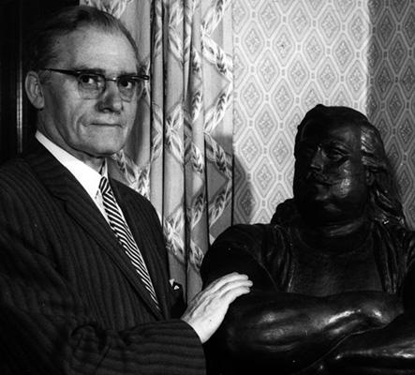

Crowley - Original Printing Plates For The ACE OF DISKS & THE SUN
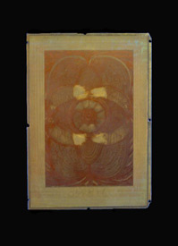
Crowley, Aleister & Frieda Harris - related material]. An original engraved colour printing plate, used to reproduce the Tarot card 'Ace of Disks' in the First edition of The Book of Thoth (1944) and the prototype samples of the Thoth Tarot cards (1943). London: OTO/Chiswick Press Ltd. [1944], 1943. The plate is metal (probably copper?) 3 3/4 x 5 1/2 inches, and is mounted on a second brass or copper sheet that is about 1/8 of an inch larger on each edge. The method used for the printing was the collotype process, which in this instance required four different printer's blocks for each illustration. These were run through the presses in sequence with different colored inks, the end result being the very high quality color reproductions that were required. The blocks within any given set varied quite dramatically in appearance. One or two would usually have sections of the background of the design cut away or deeply engraved so that there was no chance of the ink adhering to those parts of the design where it was not wanted. This gave the plates themselves a high relief, almost sculpted look. Others of the plates were lightly but very finely etched on the surface, giving them enormous detail, although it usually requires reasonably close examination of the plate to see it. In 1943 Crowley had eight sets of these printing blocks made: seven sets were for the designs for the tarot cards 'Ace of Disks', 'The Lovers,' 'The Ace of Swords,' 'The Sun,' 'The Hierophant,' 'Lust', and 'The Universe,' with the eighth set for the Rose-Cross design that would appear on the reverse side of each card. The plates were primarily struck so that color prints of the designs could be made to tip into his forthcoming 'The Book of Thoth', however he also took advantage of their availability to have a small test run of those particular tarot cards made. These he distributed to friends and acquaintances that might be persuaded to help finance the full printing of the pack. The plate is from the collection of Edward Noel Fitzgerald, (1908-1958), also known as Frater Agape, a IX degree member of the O.T.O. He had been a friend and follower of Crowley's, and remained friends with Harris after The Beast's death. The two met via Crowley, and were part of the small circle in Britain in the 1950s who continued to take an interest in his work. Harris supplied FitzGerald with a small collection of material relating to the preparation and exhibition of the Thoth tarot designs, and the publication of The Book of Thoth. Although not designed as such, the plates themselves are quite decorative. They could perhaps be mounted on a box holding tarot cards, a bookend, or simply for display in a frame. However they are displayed, there is no doubt that each plate is a unique memento of the first ever printing of one of the most significant Tarot decks ever produced, and of course of 'The Book of Thoth'. This particular engraving is moderately finely done, and presents a reverse (mirror) image of the 'Ace of Disks.' Four finger nail size rubbed patches, probably deliberately done by the printers so the ink would not adhere to those parts of the design, otherwise overall VG condition. A one-of-a-kind Crowley item. $2750
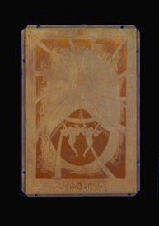
Crowley, Aleister & Frieda Harris - related material]. An original engraved colour printing plate, used to reproduce the Tarot card 'The Sun' in the First edition of The Book of Thoth (1944) and the prototype samples of the Thoth Tarot cards (1943). London: OTO/Chiswick Press Ltd. [1944], 1943. The plate is metal (probably copper?) 3 3/4 x 5 1/2 inches, and is mounted on a second brass or copper sheet that is about 1/8 of an inch larger on each edge. The method used for the printing was the collotype process, which in this instance required four different printer's blocks for each illustration. These were run through the presses in sequence with different colored inks, the end result being the very high quality color reproductions that were required. The blocks within any given set varied quite dramatically in appearance. One or two would usually have sections of the background of the design cut away or deeply engraved so that there was no chance of the ink adhering to those parts of the design where it was not wanted. This gave the plates themselves a high relief, almost sculpted look. Others of the plates were lightly but very finely etched on the surface, giving them enormous detail, although it usually requires reasonably close examination of the plate to see it. In 1943 Crowley had eight sets of these printing blocks made: seven sets were for the designs for the tarot cards 'Ace of Disks', 'The Lovers,' 'The Ace of Swords,' 'The Sun,' 'The Hierophant,' 'Lust', and 'The Universe,' with the eighth set for the Rose-Cross design that would appear on the reverse side of each card. The plates were primarily struck so that color prints of the designs could be made to tip into his forthcoming 'The Book of Thoth', however he also took advantage of their availability to have a small test run of those particular tarot cards made. These he distributed to friends and acquaintances that might be persuaded to help finance the full printing of the pack. The plate is from the collection of Edward Noel Fitzgerald, (1908-1958), also known as Frater Agape, a IX degree member of the O.T.O. He had been a friend and follower of Crowley's, and remained friends with Harris after The Beast's death. The two met via Crowley, and were part of the small circle in Britain in the 1950s who continued to take an interest in his work. Harris supplied FitzGerald with a small collection of material relating to the preparation and exhibition of the Thoth tarot designs, and the publication of The Book of Thoth. Although not designed as such, the plates themselves are quite decorative. They could perhaps be mounted on a box holding tarot cards, a bookend, or simply for display in a frame. However they are displayed, there is no doubt that each plate is a unique memento of the first ever printing of one of the most significant Tarot decks ever produced, and of course of 'The Book of Thoth'. This particular engraving is moderately finely done, and presents a reverse (mirror) image of the 'The Sun.' It does not have the great detail of the others in the set, which is particularly evident in the center or the design which is indistinct and cloudy. Overall VG condition for this one-of-a-kind Crowley item. $2750

http://www.slideshare.net/search/slideshow?ft=all&lang=en&page=4&q=aleister+crowley&qid=320d327c-4ca2-4663-898f-45f64a2e7cc9&searchfrom=header&sort=&ud=any

----------------------------

https://nathanieljharris.wordpress.com/2014/07/06/dedication/

http://www.dysgenics.com/2013/12/02/this-article-is-not-about-satanic-ritual-abuse-cult-fantasies/

http://www.howardnema.com/category/pedophilia/

---------------------------------------------------------------

https://en.wikipedia.org/wiki/J._Norman_Collie

http://countdowntozerotime.com/2014/03/21/aleister-crowley-the-beast-666-satanic-prophet-20th-century-rock-and-roll-performers/

http://www.tomegatherion.co.uk/news.htm

https://en.wikipedia.org/wiki/Nancy_Cunard

http://www.amazon.com/Aleister-Crowley-Temptation-Politics-Marco/dp/1844656969

http://www.securenet.net/tbcl/TBCL_AHOME_GalleryFB1.htm

http://www.anathemabooks.com/aa.shtml

http://www.foreverandaday.biz/Pages_info/AleisterCrowley.html

https://books.google.com/books?id=QuhIAgAAQBAJ&dq=sieveking+%22aleister+crowley%22&source=gbs_navlinks_s

http://www.amazon.com/Eye-Beholder-Lance-SIEVEKING/dp/B0000CJPVH/ref=sr_1_1?s=books&ie=UTF8&qid=1432074159&sr=1-1

http://realitysandwich.com/230073/the-lore-and-lure-of-aleister-crowley-a-dialog/

Harris relative.

https://en.wikipedia.org/wiki/Archibald_Primrose,_5th_Earl_of_Rosebery

John Bland Jameson

A collection of original typescript papers by Aleister Crowley outlining the history of his relationship with John Bland Jameson. Some pages with holograph insertions and corrections in Crowley's handwriting. About 53pp.

CROWLEY, Aleister.
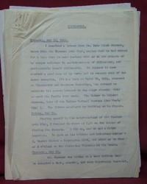

NP, [1938]. John B. Jameson (b. 1915), was an associate of Crowley's during the years 1938-1939. At the time Jameson was a wealthy young man, a member of the Theatre Arts Club, who divided his time between partying, travelling, and his thespian activities. He also had an interest in the occult, and collected Crowley's books, and eventually contacted the Beast with the hope of receiving occult tuition. Crowley apparently persuaded Jameson to purchase a 'founder's share' in his venture selling Amrita, and it was from Jameson's flat at 6 Hasker Street, SW1, that Crowley tried to launch the business. Crowley also took up temporary residence in the building, with Jameson his landlord. For a time relations were close, and Crowley suggested making Jameson an 'heir' of sorts, and apparently even declared him "Acting Grand Treasurer General of the O.T.O.," although whether he ever did anything with respect to this office is unknown. Perhaps not surprisingly the two eventually fell out, most likely over disagreements about their financial and tenancy arrangements. Crowley later wrote bitterly in his diary:John Jameson shows heroic rage / against sick men of thrice his age. Against sick women in his care. / Nothing John Jameson does not dare. Yet opposition soon dries up / The frenzy of the Pansy Pup.The papers comprise:(i) A typescript, possibly carbon, 'Memorandum' by Crowley, on the rectos only of 23 leaves of (8 x 10 inch) off-white typing paper. The 'Memorandum' outlines the history of Crowley's acquaintance with John B. Jameson during the period May 12, 1938 - November 4, 1938. The information in the 'Memorandum' was obviously reconstructed by Crowley from his diaries, letters, and memories, and seeks to document, on a day-by-day basis, all his dealings with Jameson in that period, and any arrangements or agreements that were made between them. There is something 'legal' about the tone and construction of the 'Memorandum' and it seems that it might have been prepared by Crowley in anticipation of a legal dispute. Despite this it contains much vintage Crowley: he writes in obvious dismay of his discovery that Jameson 'was completely ignorant of art,' and snobbishly described one of Jameson's parties: "There was a considerable crowd of tenth-rate theatrical and screen people; nobody present was of any social or other importance. I was considerably surprised and a little disgusted." The 'Memorandum' also reveals the basis for Crowley's poetic charge that Jameson 'raged' against 'sick women in his care.' Much delightful and interesting biographical material throughout.(ii) A collection of typescript copies and drafts of 8 letters between Crowley and Jameson. 30 pages on 25 leaves (8 x 10 inch) off-white typing paper. Of particular note is what appears to be the original draft of a lengthy (ten-page) letter from Crowley to Jameson, with numerous manuscript corrections and additions in Crowley's handwriting. It is a broad ranging letter, in which Crowley berates Jameson for his lack of work, and in particular for giving "a very mechanical reading of the Hymn to Pan" on Crowley's birthday. Much of the letter is devoted to a discussion of Crowley's business prospects. Mention is made of the O.T.O. and Amrita, but the main focus is on his plans to take over (or reclaim) AMORC: "Louis Wilkinson and Frieda Harris are quite agreeable to come out to the States with me in August, where we have Mencken and Elmer Gertz, and a number of other quite important people waiting to push us along. We shall probably need an energetic business woman, of mature age and repulsive appearance, with utterly loathsome manners suited to the American public, to complete the party." Also of considerable interest is the carbon copy of a short letter, dated February 7th, 1939, in which Crowley apparently refuses to accept Jameson's resignation from the position of Acting Grand Treasurer General of the O.T.O. - citing a technical fault in the manner of address, and his failure to present the accounts.Some creasing to the first leaf of the 'Memorandum', usual light age discoloration, otherwise near fine. (Item ID: 32627)
$1,750.00

http://www.weiserantiquarian.com/cgi-bin/wab455/32627.html

https://www.google.com/maps/@51.494371,-0.16465,3a,75y,13.02h,98.71t/data=!3m4!1e1!3m2!1sSflff-Buum97HZMz47z-xA!2e0!6m1!1e1

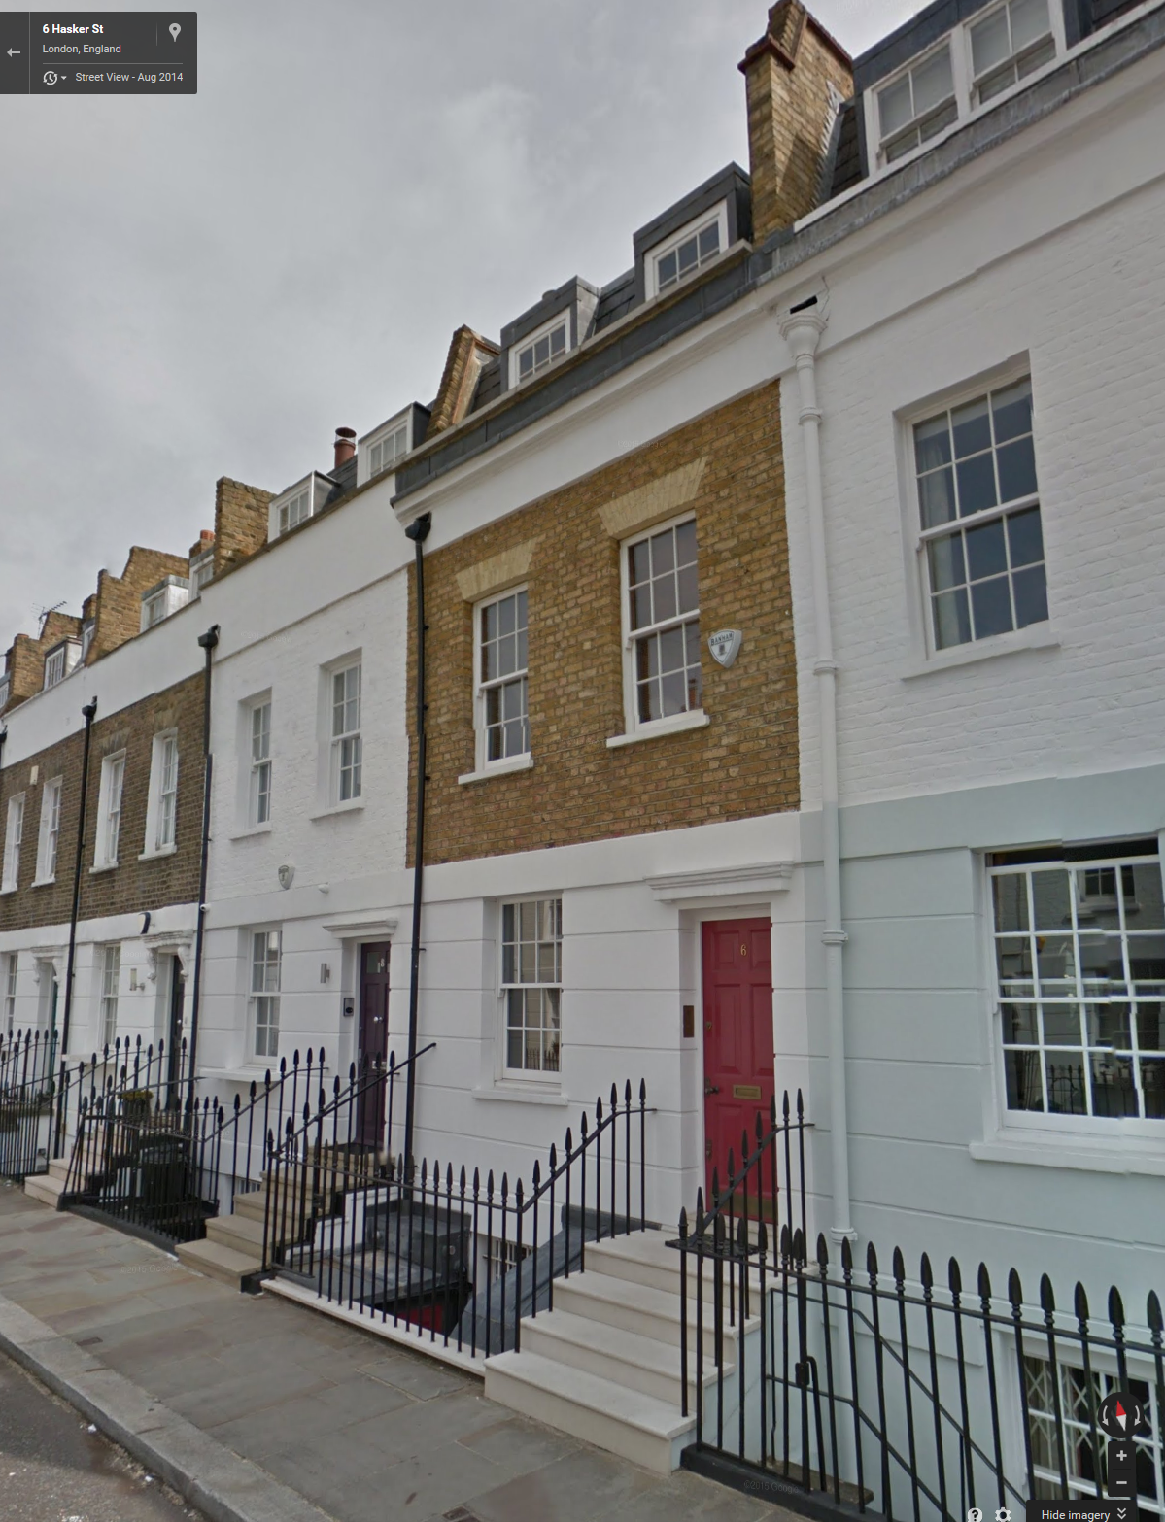

Elmer Getz - Crowley was trying to get him to fight for control of AMORC

https://en.wikipedia.org/wiki/Elmer_Gertz

he wrote a biography of Viereck

http://www.worldcat.org/oclc/4964272 and was friends with Frank Harris

http://www.imdb.com/name/nm0115471/

http://www.picturepenzance.com/photos/showimage.php?i=24932&c=763

http://www.theartstheatreclub.com/

http://www.theatrical-postcards.com/USERIMAGES/ACTOR%20A-B-22.JPG

Edgar K Bruce

J. F. C. Carter

TitleSecret Agent 666: Aleister Crowley, British Intelligence, and the OccultAuthorRichard B. SpenceEditionillustratedPublisherFeral House, 2008ISBN1932595333, 9781932595338Length288 pages

TitleMI6: The History of the Secret Intelligence Service 1909-1949AuthorKeith JefferyPublisherA&C Black, 2010ISBN1408814692, 9781408814697Length864 pagesSubjects

http://www.amazon.com/Forth-beast-Louis-Marlow/dp/B0006ED8V8

https://en.wikipedia.org/wiki/Eliza_Marian_Butler

CROWLEY, Aleister ] VEREY, The Rev. C.
Clouds Without Water. Edited from a Private M. S. By the Rev. C. Verey.
Privately Printed, London 1909 - Wrappers, Small 8vo. . xxii + 144pp. Original mottled salmon-coloured soft paper wrappers, with title across upper wrapper, lettered up spine, and with publisher's device in centre of rear wrapper (all printed in black). Printed on machine made paper. Clouds Without Water is another of Crowley's works with a complex history. Despite the statement on the title page that it was published in London, Clouds Without Water was actually printed by Renouard of Paris (who had earlier published Crowley's homo-erotic parody, the 'Bagh-I-Muattar') The book is poetry with some erotic undertones - which is presumably why Crowley playfully published it under the name of a fictitious Priest "The Rev. C. Verey" and had the words "Privately Printed for Circulation Amongst Ministers of Religion" printed on the title page! There were two issues. An undetermined (but small) number of copies were printed on handmade paper, but most, like this, were on machine made paper. The soft paper wrappers were of course fragile, and this copy has been rebacked: the original front and back wrappers have been preserved, but it has been given a new (but almost perfectly matching) spine. The job has been so well done that it is almost impossible to tell that the spine is not original, except by very close examination. Pages evenly toned, recent thelemic-themed previous owner's bookplate on front pastedown, all else VG. [Attributes: First Edition; Soft Cover]

