http://www.estelnegre.org/documents/foyot/foyot.html

Louis Umfreville Wilkinson
http://norman.hrc.utexas.edu/fasearch/findingAid.cfm?eadid=00245

Some hotels that Crowley stayed in, in the French Alps.

http://www.chalet-meije.com/en/

http://media-cdn.tripadvisor.com/media/photo-s/02/fa/e8/82/hotel-chalets-de-la-meije.jpg

http://www.cleartrip.com/places/hotels//5198/519852/images/2919478_w.jpg

http://en.wikipedia.org/wiki/Papyrus_Harris_I

https://www.google.com/search?q=hotel+de+la+meije+la+grave&safe=off&source=lnms&tbm=isch&sa=X&ei=YKgtVZ-MDsPwoASV9YCABQ&ved=0CAgQ_AUoAg&biw=1200&bih=1757#imgrc=px0YxGP3Tw-SIM%253A%3BufFdZ7ADlmTD8M%3Bhttp%253A%252F%252Fthumbs2.picclick.com%252Fd%252Fl400%252Fpict%252F330794248005_%252FCarte-postale-ancienne-LA-GRAVE-La-terrasse-de.jpg%3Bhttp%253A%252F%252Ffr.picclick.com%252FCarte-postale-ancienne-Route-des-Alpes-330844743107.html%3B400%3B266

https://www.google.com/search?q=hotel+restaurant+du+petit+nice+corniche&safe=off&biw=1065&bih=582&source=lnms&sa=X&ei=AJktVemAD4GyogTTyoCQBg&ved=0CAYQ_AUoAA&dpr=1

Kasimira Bass

http://www.foreverandaday.biz/Pages_info/AleisterWomen.html

John Rodker (Mary Butts husband)
http://en.wikipedia.org/wiki/John_Rodker

http://en.wikipedia.org/wiki/Mary_Butts

http://www.amazon.com/Exhumations-Christopher-Isherwood/dp/0413569209

where Karl and Cora Eaton Germer lived in 1928
https://www.google.com/maps/@40.766963,-73.98345,3a,75y,26.7h,90t/data=!3m4!1e1!3m2!1siZkbrJuawGc7l0spRUlqbw!2e0

The man Crowley thought to be the expert on ‘lunacy’

https://books.google.com/books?id=Du2MAwAAQBAJ&dq=cora+germer&source=gbs_navlinks_s

http://translate.google.com/translate?hl=en&sl=de&u=http://de.wikipedia.org/wiki/John_Holroyd-Reece&prev=search

James Ballingray - Murderer
https://books.google.com/books?id=lyBgGwAACAAJ

The Man who was London
https://books.google.com/books?id=7Iv_GgAACAAJ
http://www.worldcat.org/title/man-who-was-london/oclc/22424159

At Hammam Meskoutine

Before my lunch I languidly enjoy
My Bath, my book, my brandy and my boy.
For in the afternoon I must attend
To the amusement of my lady friend.

Hotel Astoria Leipzig around Crowley’s time there

http://imgl.aklex.de/14665a.jpg

today

http://static.panoramio.com/photos/large/18650614.jpg

Hotel Atlantic - Hamburg

http://www.cleartrip.com/places/hotels//2131/213168/images/22891_18_b_w.jpg

Birven

http://www.heinrichschwabverlag.de/1005.html

http://www.parareligion.ch/sunrise/birven.htm

http://www.parareligion.ch/list.htm

http://www.markhorrell.com/blog/2014/is-k2-the-new-everest/

Ivy Cottage Knockholt Kent

https://www.google.com/maps/place/Ivy+Cottage,+Burlings+Ln,+Knockholt,+Sevenoaks,+Kent+TN14+7PD,+UK/@51.30502,0.089139,3a,52.5y,294h,90t/data=!3m4!1e1!3m2!1sYuJCe6wX9HoSGDIy89CMUQ!2e0!4m7!1m4!3m3!1s0x47df54809fe53bb3:0x57b36a81cfd3a300!2sIvy+Cottage,+Burlings+Ln,+Knockholt,+Sevenoaks,+Kent+TN14+7PD,+UK!3b1!3m1!1s0x47df54809fe53bb3:0x57b36a81cfd3a300!6m1!1e1

Oddenino’s
http://www.oldcooksbooks.com/master_book_by_let_search.php?order_by=&category=&page=13

Kalpaka

http://enfolding.org/east-meets-west-new-thought-thelema-and-the-holy-order-of-krishna/

@book{bogdan2014occultism,
title={Occultism in a Global Perspective},
author={Bogdan, H. and Djurdjevic, G.},
isbn={9781317544470},
url={https://books.google.com/books?id=Y15\_BAAAQBAJ},
year={2014},
publisher={Taylor \& Francis}
}

http://universitypublishingonline.org/acumen/chapter.jsf?bid=CBO9781844657179A015&cid=CBO9781844657179A016

http://en.wikipedia.org/wiki/Percy_Street Eiffel Toure Rest.

http://www.austria-trend.at/Parkhotel-Schoenbrunn/en/ only 4.5 stars

Hotel Eden

https://www.youtube.com/watch?v=wk7EqIYy9eI

http://www.cabaret-berlin.com/?p=1092

Albemarle Court Albemarle St. Mayfair W.1.

Ristorante Italiano Venezia Berlin w15 Kurfustendamm 34

Entwurf Architekt Adam Muller

http://en.wikipedia.org/wiki/C._E._M._Joad
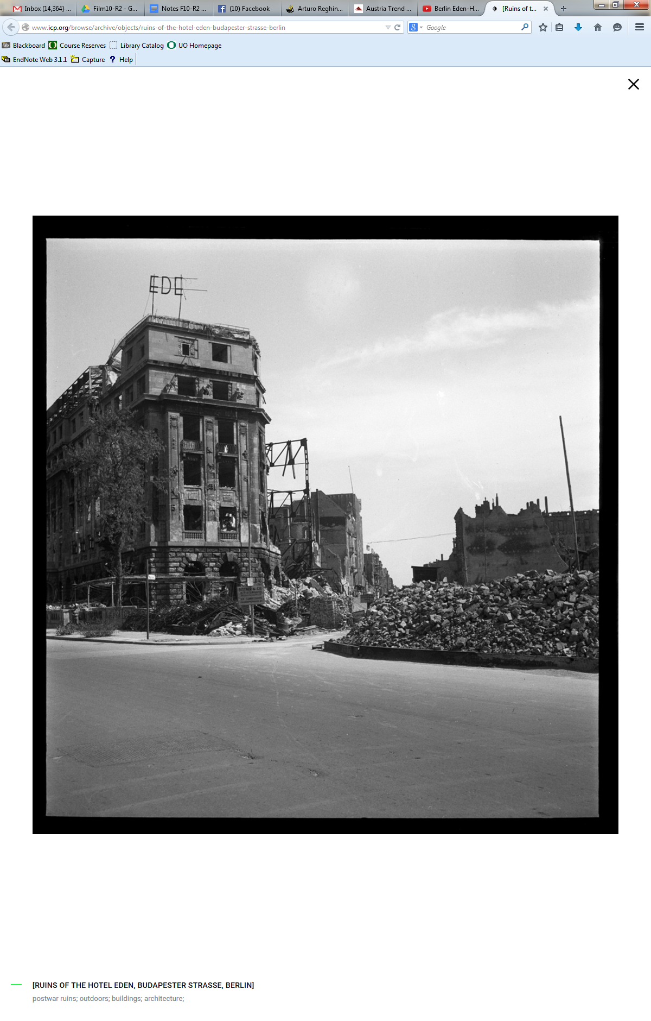

http://www.icp.org/browse/archive/objects/ruins-of-the-hotel-eden-budapester-strasse-berlin

The Eden-Hotel
Miniature golf course on the roof of the Eden-Hotels

On the road triangle Budapesterstrasse / Kurfürstenstraße / Nürnberger Straße opposite the Zoo-Aquarium, the Eden Hotel was to the historic address Kurfürstendamm 246/247. After renaming the Kurfürstendamm section in Budapest street address Budapesterstrasse 18 [12] was now located at this point of the Olof Palme Platz. Regular at Berlin-stays was the writer Jakob Wassermann. The hotel bar was one of the most elegant of the city, according to high prices were. Here, successful writers, actors and artists such as Heinrich Mann, Albert Bassermann, Gustaf or Erich Maria Remarque, [13] but also met Wilhelm Herzog [4] and Marlene Dietrich [14]. The painter Max Beckmann documented the Bar in 1923 in a woodcut called "Group Portrait Eden Bar", Christopher Isherwood describes in his "Berlin Stories" an interview with the German air Fritz Wendel, which took place here. [15] notoriety reached the hotel 1919th At that time here was the headquarters of the Guards Cavalry Rifle Division. On January 15, the illegally arrested Karl Liebknecht and Rosa Luxembourg were deported here, by 22 clock of the day was here, the decision both to execute. While Luxembourg has been a few meters away shot and thrown her body into the nearby Landwehr canal, the murderers of Liebknecht brought the corpse of his place of execution in the Tiergarten back to the hotel and gave him in the opposite station as "unknown corpse" from.

http://de.wikipedia.org/wiki/N%C3%BCrnberger_Stra%C3%9Fe_%28Berlin%29

https://www.google.com/search?q=Silver+Grill%22.+Rue+des+Augustins&safe=off&source=lnms&tbm=isch&sa=X&ei=flBNVdKvKM6zogS9soCADg&ved=0CAgQ_AUoAg&biw=1065&bih=582

